

INSTRUCTIONS FOR COMPLETING THE

SLOCAN VALLEY LEGACY FUND

GRANT APPLICATION

Steps to Submit an Application

1. Create an online account or use account from previous year
2. Upload a letter of support from your sponsor organization if you are not a qualified donee
3. Complete the online application form
4. Upload a completed budget template
5. Upload any additional supporting documentation
6. Submit the completed application

STEP 1. CREATING AND USING AN ONLINE ACCOUNT

If you submitted an online application last year, use your existing login credentials and skip to Step 2 on Page 4.

Follow the link on our website <https://www.slocanvalleylegacy.com/grants/> to create an account or login. There is a video available from the login screen that outlines the process, but we suggest you read the instructions below.

When creating an account, pay particular attention to the information requested

* for the *organization* carrying out the project
* for the *person creating the account* on behalf of the organization

**Leave the Email Address and Password blank**, and click



Issues with creating an account or accessing an existing account? Contact admin@ospreycommunityfoundation.ca

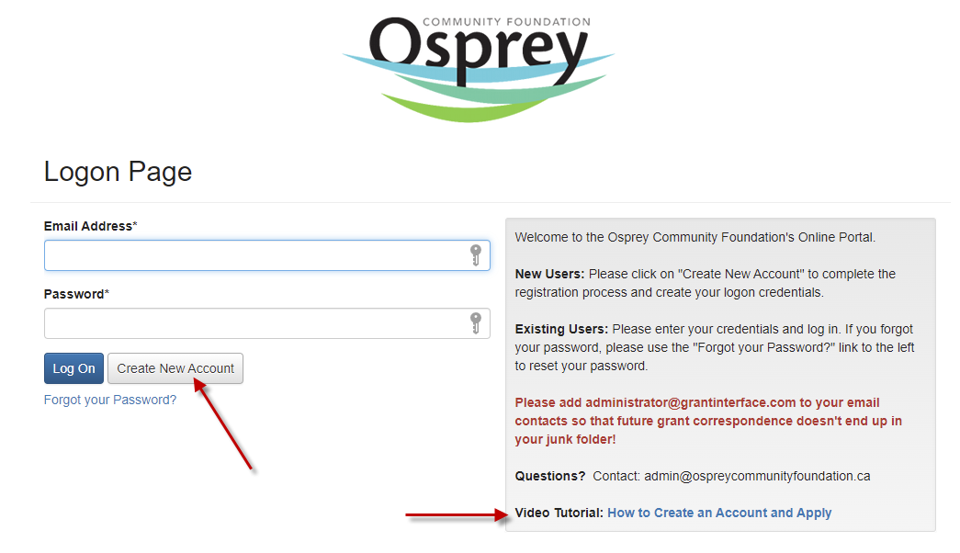

Enter the information for **the organization that will be carrying out the project** as follows:

|  |  |  |
| --- | --- | --- |
| Field | Required? | Notes |
| Organization carrying out project | Yes | Enter the name of the organization that will be carrying out the project |
| CRA Registration Number | Yes | If the organization carrying out the project is a qualified donee, enter the CRA registration number.  If the organization carrying out the project is NOT a qualified donee, enter 123456789RR1234.  You cannot leave this field blank or enter any other characters. |
| Website | No | If your organization has a website, enter the URL (web address) here.  If your organization does not have a website, leave blank. |
| Telephone number | Yes | Enter the organization’s phone number in the format ###-###-#### x###  If the organization does not have its own phone number, enter your phone number. |
| Organization email | No | If your organization has its own email address (e.g., [ValleySeniors@gmail.com](mailto:ValleySeniors@gmail.com)), you may enter it here, but it is not required. |
| Address 1 | Yes | Enter the mailing address for the organization (street address or post office box number) |
| Address 2 | No | If there is a second part to the organization’s mailing address, enter it (e.g., Suite #402) |
| City | Yes | Enter the city |
| Province or Territory | Yes | Enter the 2 letter postal abbreviation for the province or territory without periods (e.g., BC) |
| Postal Code | Yes | Enter the postal code in the format A#A #A# |
| Country | No | Select from the drop down options or leave blank. |

Check to make sure all required fields have been completed correctly, then click



Enter the information for t**he person who will be completing the grant application** as follows:

|  |  |  |
| --- | --- | --- |
| Field | Required? | Notes |
| First Name | Yes | Enter your first name |
| Last Name | Yes | Enter your last name |
| Suffix | No | Enter if appropriate (e.g., Jr, III) |
| Business Title | Yes | Enter your relationship to the organization carrying out the project (e.g., Board Chairperson, Project Manager, Administrator, etc.) |
| Email / Username  Email / Username Confirmation | Yes | An email address is required for account creation. It will be the user ID for accessing the grant application and for all communications. |
| Telephone Number | Yes | Enter in the format ###-###-#### x### |
| Mobile Number | NO | Enter in the format ###-###-#### |
| Address 1 | Yes | Enter your mailing address or click  to autofill from the previous page |
| Address 2 | No | If there is a second part to the mailing address, enter it (e.g., Suite #402) |
| City | Yes | Enter the city |
| Province or Territory | Yes | Enter the 2 letter postal abbreviation for the province or territory without periods (e.g., BC) |
| Postal Code | Yes | Enter the postal code in the format A#A #A# |
| Country | No | Select from the drop down options or leave blank |

Check to make sure all required fields have been completed correctly, then click



Answer “Yes” to the question regarding whether you are the Executive Officer or Authorized Signatory for the organization carrying out the project. *SVLF does not require this information, but you cannot advance without entering a response.*

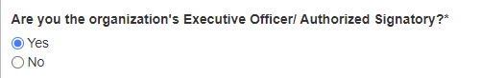



Click

Enter a password that will be used with your user ID to log in to the grant application site. The password must be

* minimum 6 characters
* letters, numbers
* special characters: ! @ # $ % ^ * ( )

Confirm your password. *You may wish to write it down for future reference.* You will need it to log in to the application site.

Click



You will receive an automated email to confirm your user ID (email address) and provide a link to the application portal. Follow the link to login with your user ID and password.

If you do not receive the confirmation email, contact admin@ospreycommunityfoundation.ca

STEP 2. OPENING THE LEGACY FUND APPLICATION

Log in using your user ID and password.



Look for the Legacy Fund logo in the list of applications available, and click

Note that there may be other grant opportunities listed so be sure you are clicking to apply for the SVLF grant.

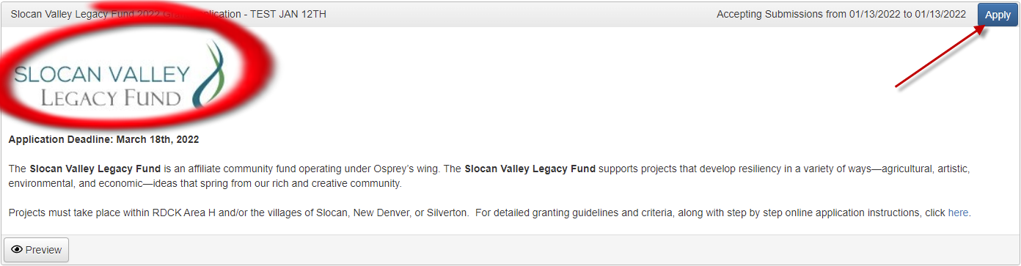

Verify the information entered in your account is correct for both the *Applicant* and the *Organization* carrying out the project. If changes are needed, contact [admin@ospreycommunityfoundation.ca](mailto:admin@ospreycommunityfoundation.ca).

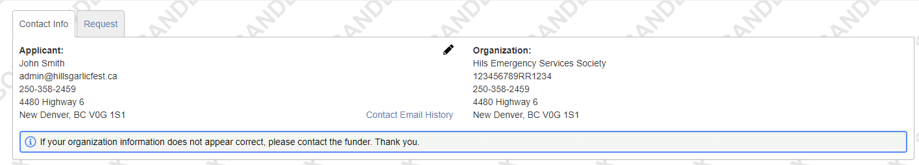

To get a PDF copy of the application to download or print, click

It will open in a new tab on your browser so you can return to the actual application.

**THE ONLINE APPLICATION SHOULD AUTOMATICALLY SAVE; HOWEVER, WE RECOMMEND SAVING OFTEN.**



Scroll to the bottom of the page and click as you work.

Use the Previous and Next buttons to move from section to section. **Do not use the browser “Back” button.**

Responding to the Application Questions

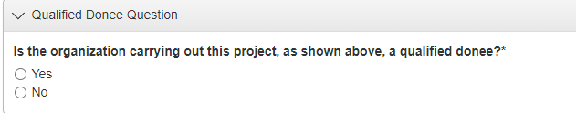

A qualified donee is a registered charity, Canadian municipality, or school district (if registered as a charity).

* If your organization is not a qualified donee, answer “No” to enter the information for your sponsor organization.
* If your organization is a qualified donee, answer “Yes.”

Note: If you are not a qualified donee, you need a letter of support from your sponsor organization signed by an authorized signatory (usually the president or treasurer). Use the “Upload a file” button to include this letter of support with your application (required).

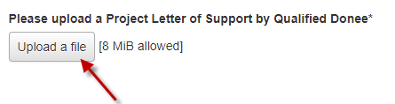

STEP 3: COMPLETE THE APPLICATION

Enter the name of your project, a brief description of your project, and the amount of funding you are requesting from SVLF.

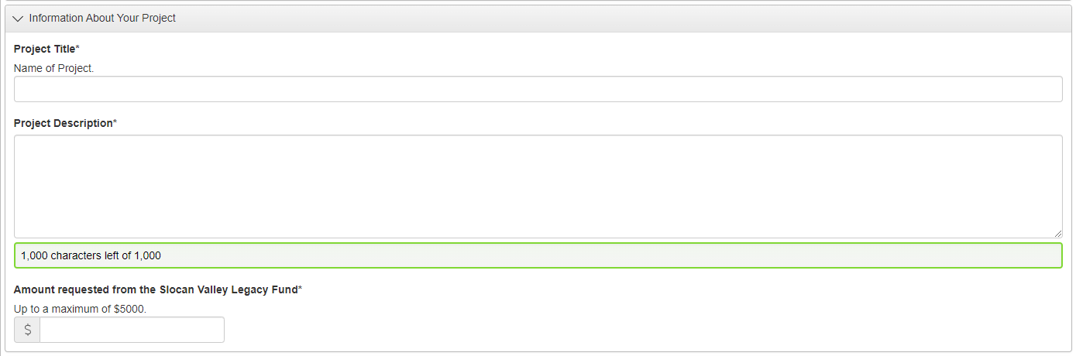

Enter the expected start and end dates for the project. Clicking in the box brings up a calendar. Use the scroll arrows to find the appropriate month, then click on the date.

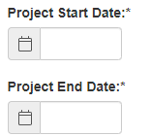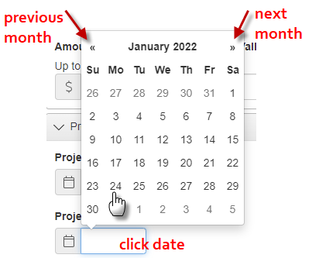

Respond to the remaining questions as requested. You can prepare your responses in a word processing document and copy/paste into the response areas. **Remember to save often. Remember to use Previous and Next to move from section to section.**

STEP 4: PROJECT BUDGET

  
Click the embedded link “Slocan Valley Grants Budget Template” to download the budget template. Save it to your computer, complete it, save it, then click

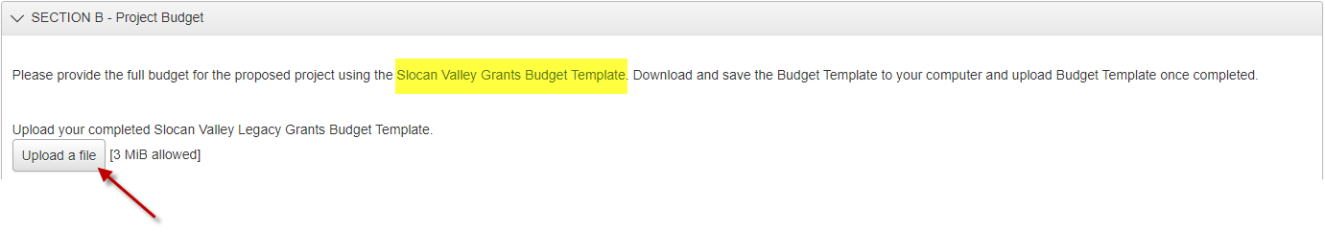

Instructions for completing the budget template are available on our website <https://www.slocanvalleylegacy.com/grants/>

STEP 5: ADDITIONAL DOCUMENTATION

If you have additional documents such as letters of support or price quotes that support your budget, they can be uploaded in this section. Up to 4 documents can be uploaded (note maximum file sizes allowed).



Saving and Returning to the Application

You can save the application, leave and return at another time to resume. To resume working on an existing application, after logging in, from the Dashboard, click the “Edit Application” link.

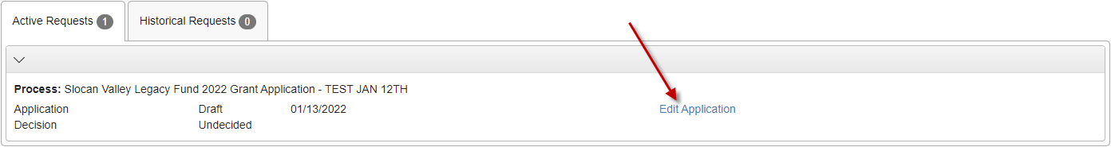

STEP 6: SUBMITTING THE APPLICATION

Review your responses to ensure accuracy. You cannot edit responses once you submit the application.

To submit, click the “Submit Application” button at the bottom right of the screen.



After submitting the application, if you realize there are changes necessary prior to adjudication by the Granting Committee, please call Ellen at 250.358.2459.

Collaborating on the Application



Click the Collaborate button at the top of the page to enable multiple people to work on the application. Enter the email address of a potential collaborator, select the appropriate level of permissions (view only, edit the application, submit the application), and add a message.



Click

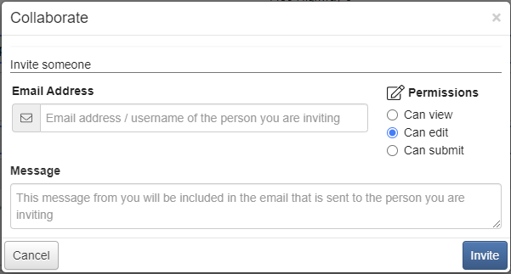

Downloading the Application to View and/or Print

Use the appropriate buttons as indicated:

|  |  |
| --- | --- |
|  | view uploaded documents (e.g., letters of support); this button only appears after at least one document has been uploaded; If only one document has been uploaded, it will be displayed. If more than one document has been uploaded, select from the list in the upper right corner to display. |
|  | download a PDF version of the completed application including any uploaded documents |
|  | open a PDF version of the application without any entered responses |

After viewing documents, use the Close button to return to the application.

